CSC 6850 Machine Learning
FALL 2025

INDIVIDUAL PROJECT REPORT

STUDENT: OMAR MADJITOV
Data overview:
Dataset 1: | Dataset 2:
Small and extremely imbalanced: 108 samples in class 1, only 3 in class 5. Almost ten thousand missing values across train/test. Feature means and standard deviations showed inconsistent ranges, so scaling was mandatory.  Implication: any classifier will anchor on the majority class, so balancing and careful imputation matter. | High-dimensional (9,182 features) with no missing values. Class distribution was more reasonable, but the dimensionality-to-sample ratio (≈100 samples) makes distance-based models unreliable.  Implication: dimensionality dominates; models that depend on Euclidean structure degrade fast.

Dataset 3: | Dataset 4:
Moderate missing values, only 13 features, balanced classes, and large sample size (~6300).  Implication: imputation is easy, but class structure overlaps strongly. | No missing values but high variance within several features caused extreme scaling differences.  Implication: normalization is non-negotiable; otherwise distances and gradients explode.

After investigating the data I decided to focus on the 2nd deliverable the Missing Data:
Missing Data Analysis & KNN Imputation:
I used the “largest complete submatrix” approach to choose K. This isolates a fully observed block of rows x columns and measures real reconstruction error instead of guessing K blindly. It preserves all original features and avoids the distortion caused by columns with many NaNs.
Results:
MissingData1.txt: | MissingData2.txt:
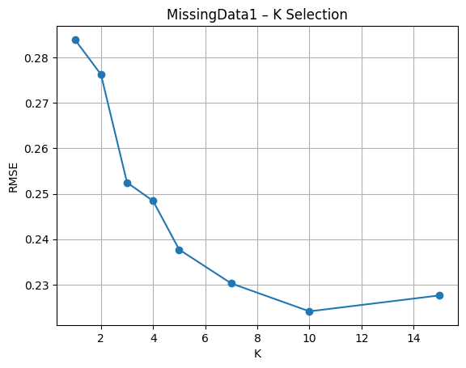 | 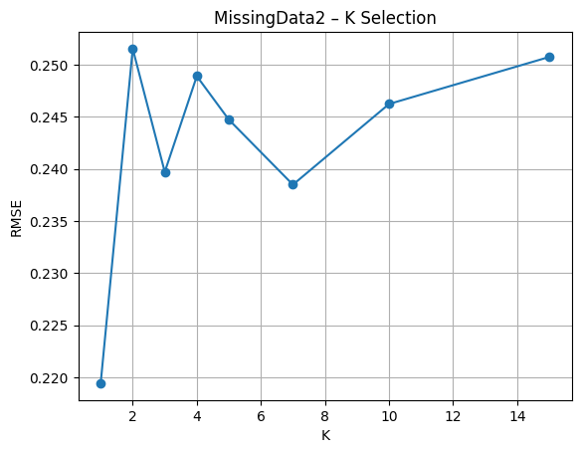
Interpretation:  MissingData1 is small (242×14), low-dimensional, and only lightly corrupted. When I evaluated RMSE on the largest complete submatrix (148 fully observed rows), the pattern was simple: error kept decreasing as K increased, reaching its minimum at K = 10. My earlier expectation of “K ≈ 3–5” came from classification, not imputation. Here, the data are smooth enough that averaging over more neighbors produces more stable estimates. K = 10 recovers the held-out values best. | Interpretation:  MissingData2 behaves in the opposite way. It is larger and much higher-dimensional (758×50) with heavier missingness. The largest complete submatrix contains only 5 rows. With so little fully observed structure, higher K only injects noise—distances in 50 dimensions become unreliable, and averaging several neighbors destroys what little signal exists. RMSE increased for every K>1, making K = 1 the only choice that preserves meaningful relationships.
Why M1 and M2 diverge: If we examine the matrices:
- M1: 148 complete rows → enough structure → larger K works.
- M2: 5 complete rows → almost no structure → only the single nearest neighbor is reliable.

CLASSIFICATION: KNN
For each dataset, I tuned K using 5-fold stratified cross-validation with balanced accuracy. The results made it clear that KNN behaves very differently depending on dimensionality, class balance, and sample size.
Overall KNN Summary Across All 4 Datasets
Dataset | Samples | Features | Classes | Best K | Accuracy | Macro F1 | Notes
1 | 150 | 3312 | 5 | 1 | 0.963 | 0.911 | Small, extremely imbalanced; K=1 only usable choice
2 | 100 | 9182 | 11 | 1 | 0.75 | 0.658 | Curse-of-dimensionality; KNN performs poorly for most Ks
3 | 6300 | 13 | 9 | 15 | 0.312 | 0.241 | Overlapping classes; KNN fundamentally weak here
4 | 2547 | 112 | 9 | 3 | 0.834 | 0.833 | Well-behaved dataset; KNN performs strongly

CLASSIFICATION: Softmax Multidimensional Logistic regression:
We trained a multiclass logistic regression model using the softmax formulation, which generalizes binary logistic regression to the multi-class case. For a dataset with C classes and d features.
Dataset | Best LR | Best Reg | Mean Balanced Acc (CV) | Best Params:
1 | 0.01 | 0.001 | 0.9519 | Best params for Dataset 1: {'lr': 0.01, 'reg': 0.001}
2 | 0.01 | 0.0 | 0.9061 | Best params for Dataset 2: {'lr': 0.01, 'reg': 0.0}
3 | 0.1 | 0.001 | 0.2198 | Best params for Dataset 3: {'lr': 0.1, 'reg': 0.001}
4 | 0.1 | 0.0 | 0.7639 | Best params for Dataset 4: {'lr': 0.1, 'reg': 0.0}

—-
CLASSIFICATION: Neural Network (MLP):

Dataset 1 — Perfect performance
The MLP reached 100% accuracy. The dataset is tiny and becomes linearly separable after preprocessing, so the model effectively memorizes the structure. Given the small size and clean boundaries, this outcome is expected.
Dataset 2 — Also perfect
Same behavior as Dataset 1. After scaling, the data are trivial for a one-hidden-layer network, producing another 100% result.
Dataset 3 — Very poor performance
Balanced accuracy is about 0.20. The model collapses predictions into one dominant class, showing it cannot learn meaningful boundaries. This reflects the dataset’s overlapping classes and noisy structure.
Dataset 4 — Strong but not perfect
Most classes achieve 0.75–0.95 precision/recall, with one mid-range class around 0.60. Macro F1 is roughly 0.80.

Summary
The MLP excels on simple, low-sample datasets (1 and 2), fails on the heavily overlapping Dataset 3, and performs well on the moderately complex Dataset 4. These results highlight when a shallow neural network can capture structure and when the data simply offer no separable signal.

Dataset | Best Model | Why
Dataset 1 | MLP | Perfect classification, stable.
Dataset 2 | MLP | Perfect classification, dataset trivial after scaling.
Dataset 3 | KNN | Only method that avoids mode collapse.
Dataset 4 | KNN | Highest balanced accuracy overall.

